2nd June 2016

Successful “REIFEN 2016” for YOKOHAMA

The Japanese Tyre manufacturer YOKOHAMA concluded an eventful week at “REIFEN 2016”, one of the leading Tyre Trade fairs in the World which has been held every two years in Essen, Germany.

This year around 20,000 visitors, were able to see at first hand the latest developments in tyre technology and latest products from 675 exhibitors joining from 43 countries. A major highlight of the show was YOKOHAMA’s elegant and custom-designed booth which was very well attended throughout the duration of the show. A number of YOKOHAMA Europe representatives – European Head Office of the Japanese Tyre manufacturer, as well as European country distributors were also at hand to offer advice and made themselves available to the many visitors and business partners joining the tyre fair.

Also at the show, a TV spot was produced which summarises YOKOHAMA´s presence at REIFEN 2016. This can be viewed on the German N-TV channel on 27.06.2016 at 08:26 hours, 29.06.2016 at 07:54 hours and 01.07.2016 at 06:43 hour (CET).

A full selection of tyre products from the YOKOHAMA Line-up including Passenger Car, Original Equipment, SUV, Truck and Bus and Off-The-Road tyres were on display with interactive explanations and there was also a special Chelsea FC Corner, highlighting the partnership agreement between the English Premiership Club Chelsea FC and YOKOHAMA as Official Shirt Partner as well as the BluEarth-A AE-50 Chelsea FC Edition tyre.

Within the ADVAN area, YOKOHAMA’s premium High Performance tyre brand was showcased with the new ADVAN FLEVA V701 aiming to set the all new standard of High Performance as a sporty tyre, and featuring extreme wet grip, emotional handling, low noise and a cool and attractive design proving very popular. The ADVAN FLEVA V701 tyre reinforces the company’s premium product line "ADVAN", with a new concept focused on increasing drivers' control of the car. The new high-performance sport tyre brings greater driving pleasure to a diverse group of car owners, from sport car lovers to tuning enthusiasts to drivers of limousines, compact cars and CUVs.

The ADVAN A052 described as “The ultimate street sporty tyre, with the most extreme grip ever” was also highlighted at “REIFEN 2016”. In addition to these, two new ADVAN products were on display - ADVAN NEOVA AD08R together with the Motorsport tyres A005 and A006 for wet and dry.

YOKOHAMA’s proud and long relationship with the most premium tyre manufacturers in the world was also prominent in the Original Equipment section with YOKOHAMA’s latest achievements in OE and included the Flagship tyre ADVAN Sport V105.

Also launched this year and featured at “REIFEN 2016”, was the GEOLANDAR A/T G015, which is a real All-Terrain, On-Off Road tyre for SUVs developed to support the active vehicle lifestyle of drivers by delivering superior performance on any road surface under any weather condition. The use of an optimised tread pattern and new compound increases the tyre’s wear performance and traction performance on wet and snow-covered roads, hence displaying the snow flake marking.

Two Concept Tyres highlighting the latest innovation from the Japanese Tyre manufacturer were also displayed with the BluEarth Air – lightweight tyre and the aerodynamic Outside Fin tyre, offering innovative technology and a glimpse into the future of tyres.

YOKOHAMA has a full range of Winter tyres too and at “REIFEN 2016” exhibited the iceGUARD and the W*drive as well as some of its commercial tyres, including TBS tyres such as the BluEarth 110L displayed for the first time in Europe - also the first TBS product

which has been included in the BluEarth lineup - and the 902W Winter drive. The full range of commercial tyres from YOKOHAMA was completed with a featured OTR tyre.

For this edition of REIFEN 2016 YOKOHAMA also displayed the very elegant Mercedes-Benz C-Class (W205) which was branded in YOKOHAMA colours and expertly tuned jointly by PIECHA, who took care of the bodykit and Performmaster GmbH who expertly handled the electronics. The ADVAN Sport V105, YOKOHAMA’s flagship tyre was selected as the chosen tyre for the car.

The YOKOHAMA Europe App was also promoted during the show and more details are available on:

www.yokohama-online.com/app

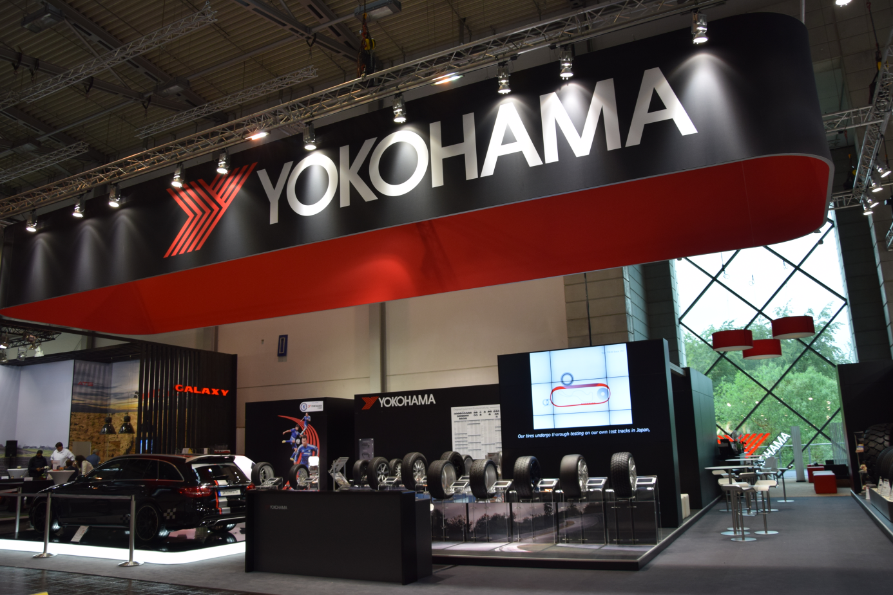
YOKOHAMA Booth at REIFEN 2016

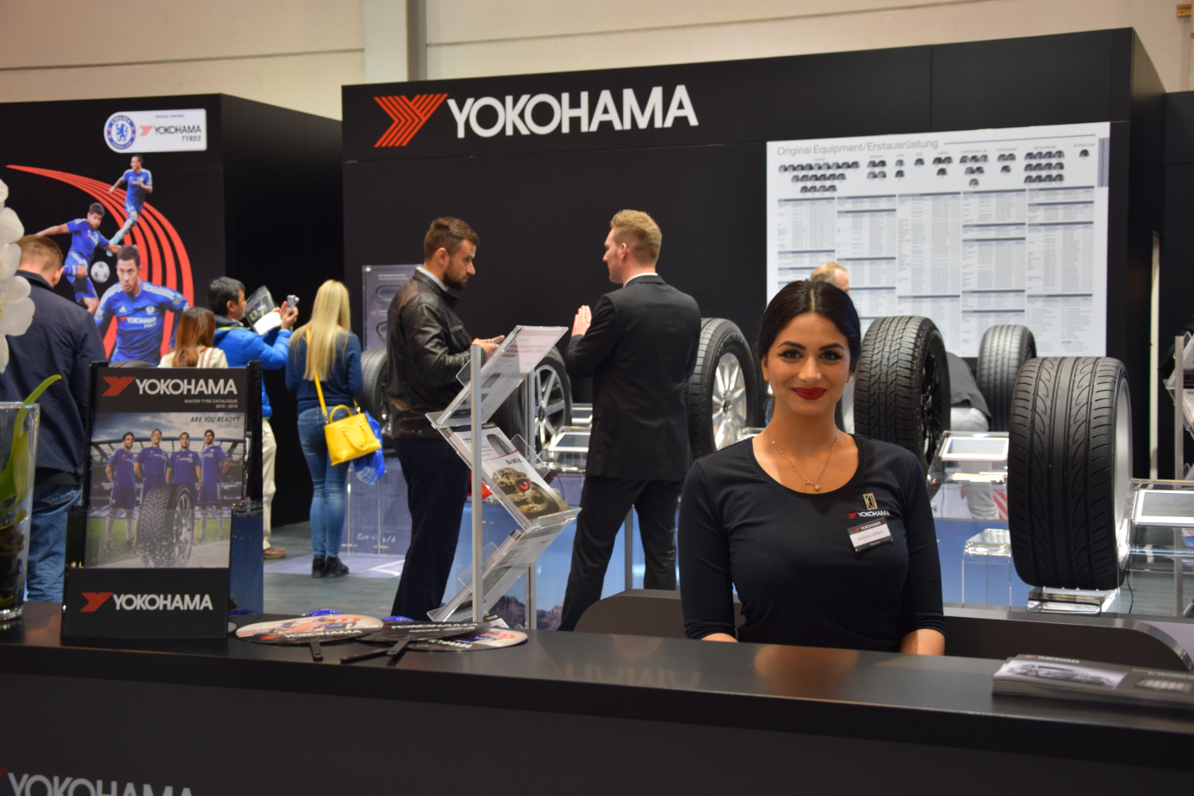
Welcome smile at the YOKOHAMA Booth

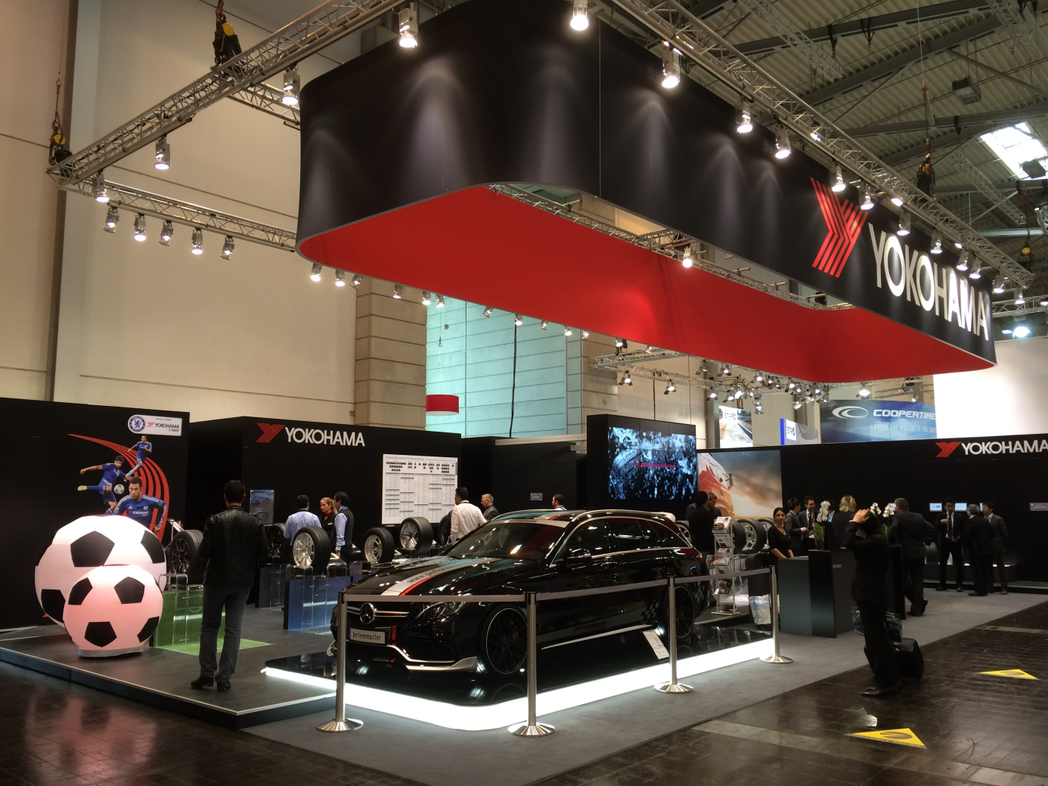
General view of the Elegant YOKOHAMA Booth at REIFEN 2016

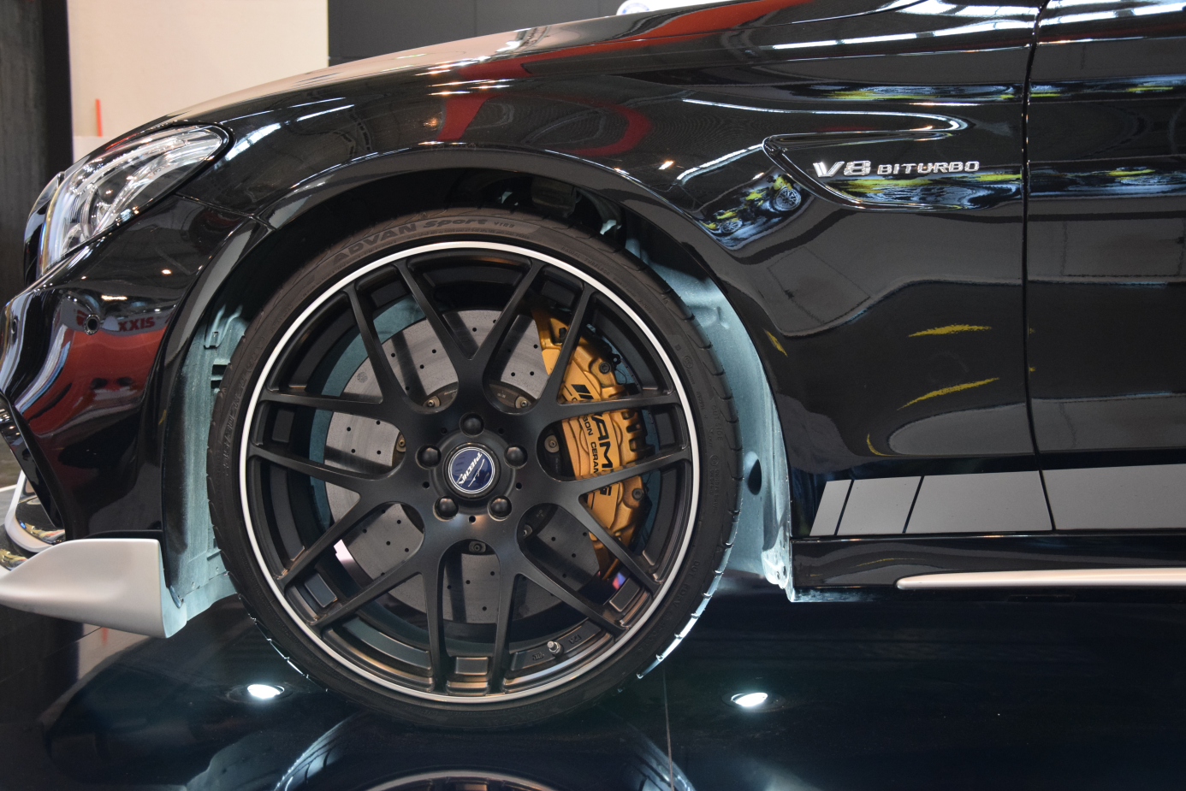
ADVAN Sport V105 on display car

